***System Design Group Project***

***(Health and Fitness System)***

*Mid project Review*

*Muhammad Ijlal*

*UOB # 14031197*

*Group members*

*Muhammad Mudassir 14031238*

*Faheem Abbas Shah 13031162*

*Muhammad Asad 14031193*

***Monday, March 20, 2017***

# ABSTRACT:-

Inactive and lazy lifestyles are a reason for many chronic diseases [1]. People with less active routines have a greater risk of high blood pressure and heart diseases [2]. In order to integrate physical activities in to people’s lifestyle a number of devices are available in the market including treadmills, cardio exercise bikes and some wearable health management devices. This paper proposes a similar device for the use of common people. By using simple hardware the user will be provided with information regarding his heart rate, physical activity and fitness. By using this portable device user will be able to monitor his health and build an active routine to keep himself from diseases caused by inactive lifestyle.

Table of Contents

ABSTRACT:- 1

Introduction 3

Top Level Design 3

Displaying Current Date and Time 4

Heart Rate Measurement 4

Cadence Measurement 5

Recording and Graphical Representation 5

Individual Contribution 5

Literature Review 5

Documentation 5

Technical contribution 5

Conclusions 6

Bibliography 6

Appendix 7

# Introduction

Modern lifestyles are getting busier with sedentary activities day by day. People spend more time performing physically idle activities and eat junk food while giving little attention to their health and fitness. This behavior leads to many diseases and effects the physical, mental and emotional health [3]. Heart disease is major killer and is included in the list of diseases caused by inactive lifestyle. Health and fitness monitoring systems are a smart way of introducing exercise into a person’s lifestyle. Treadmills and cardio exercise bikes are the conventional monitoring devices but they can only be used indoors and for a single type of exercise. In contrast, portable health and fitness systems are a step towards a healthy word. With these portables devices one can have the same features anywhere and during different type of workouts. Portable health monitoring devices are also present in the market like products by “fitbit**”** [4] a health and fitness company and Under Armour Health box [5]. These devices provide quality monitoring services but the prices are high for a common user. However, products like Gym watch sensor [6] are available at a reasonable price but the service drops considerably as well. In this project we are going to provide a similar solution that can help an individual in keeping a track of his health and fitness. The main idea of the project is to design a wearable device using simple hardware, which along with the functionalities of displaying current time and date in real time, can also provide health related information in a reasonable price. Keeping the product portable we aim to provide the user with a system that is capable of monitoring cardiac health and physical activity and can assist the user in achieving a healthy life style by tracking his physical fitness. A person who will be kept informed about his health will remain concerned about completing his exercise and will be less prone to deadly diseases.

# Top Level Design

The system requirements includes finding the heart rate and cadence of the user and displaying it in real time on a display. It also involves saving the data and providing the user with graphical reports of his progress. The project could thus be divided in to following parts

1. Displaying current time and date.
2. Measuring and displaying heart rate with an accuracy of ${}_{-}^{+}{1 }$ bpm.
3. Displaying the speed and distance covered with an accuracy of ${}_{ -}^{+}2 \%$.
4. Recording and preparing a graphical report from the data.

To design the product with these functionalities a number of sensors and microcontrollers are required. The solution proposed by our team includes the use of Arduino Uno and Arduino Nano along with some sensors and a color display. The Diagram below shows an architectural view of the proposed solution fig(1).

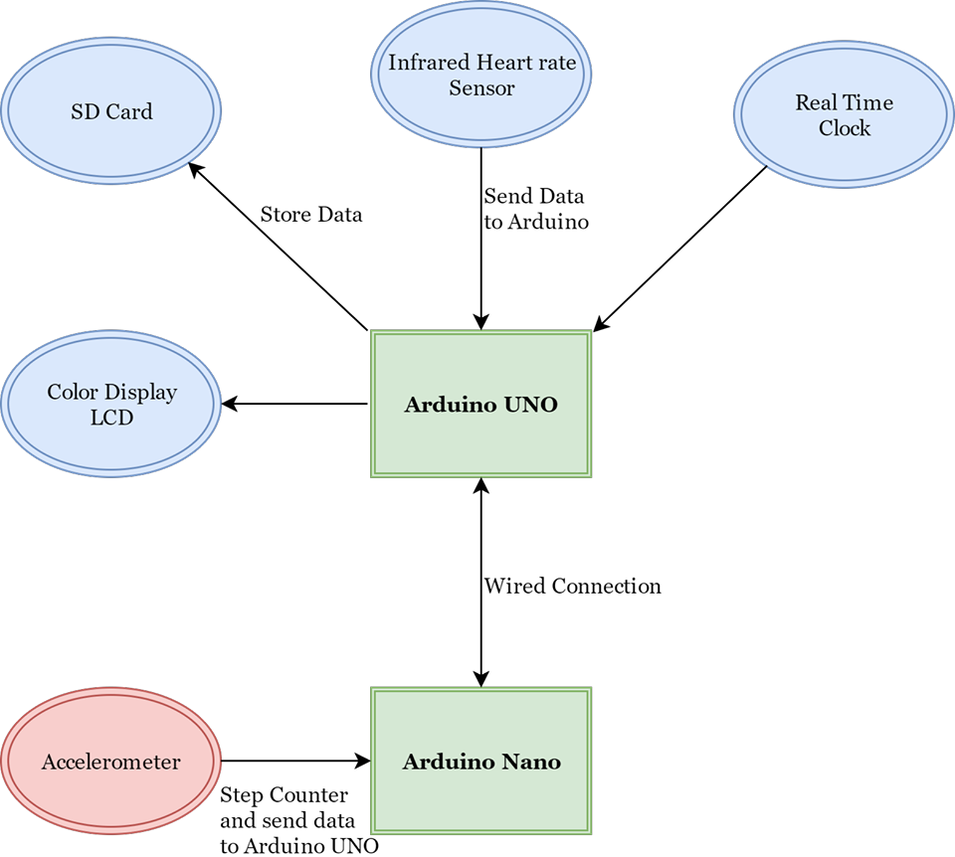

Fig 1 (Proposed System)

## Displaying Current Date and Time

Real time date and time information is to be displayed by the system. This can be performed by using Arduino internal timer interrupts or by using an external real time clock (RTC) module. Both the methods provide effective accuracy. We choose RTC over Arduino timer interrupts because RTC is constantly powered by a cell for the sole purpose of keeping track of the time and date whereas Arduino interrupts will lose information once power to the system is removed.

## Heart Rate Measurement

The heartbeat of a person can be measured from multiple parts of his body like chest, wrist and finger. Two major type of sensors used for this purpose are pressure sensors and infrared light sensors [7] [8]. The option of measuring the heart rate using infrared light from finger proves to be the most effective approach because of its accuracy and ease of use [9]. So we decided to use SEN-11574 an infrared light sensor to measure the heartbeat of the user. This sensor provides a constant value of blood level in the veins of a fingertip. From these continuous values the peak is identified and counted to find the heartbeat, which can then be displayed and stored.

## Cadence Measurement

Cadence can be measured using different techniques and sensors. Three of the methods which we were able to identify were.

1. Use of GPS positioning to find the change in position.
2. Using Accelerometer to find the distance covered.
3. Using pressure sensors to count the steps taken.

We discarded the concept of using GPS system as it will not work when the person is exercising indoors on a treadmill. The use of pressure sensors requires repeated calibration of distance covered per step to provide accurate measurements. Accelerometer is a difficult technology to integrate but can provide accurate measurements. We decided to use the analog accelerometer adxl335 for cadence measurement. For future improvements we kept the idea of integrating both accelerometer and pressure sensors for increased accuracy.

## Recording and Graphical Representation

The data generated from the sensors is to be recorded for future representation. For this purpose we decided to use SD card. The data generated would be organized and stored in the SD card for later representation. For graphical representation of the stored data we decided to build an Android app with a simple interface for the user to view his progress and set and track his exercise routine.

# Individual Contribution

## Literature Review

Individual contribution towards the project started from preforming literature review and finding possible techniques and technologies to build an effective low cost system. During this process, went through a number of articles and existing solutions to figure the methods that can be used to achieve the requirements. During this process I came through an Arduino board recently launched Arduino Primo Core [10]. This board due to its specification was proving to be an excellent microcontroller for our project. However, I was unable to get the part but have included it in the future improvements.

## Documentation

After performing a complete literature review and building a complete idea of what the solution is going to be and how it will be implemented a proposal was written and submitted by me.

## Technical contribution

The main part assigned to me was to generate a graphical display system which can display the stored data. The decision of making an android app for this purpose was taken. As measuring data was our first requirement so helped my group mates in understanding the integration of the sensors. Being a new learner of android development I have started acquiring the knowledge and skills required to build an app according to the requirements. Once the learning phase is complete I will start implementation process. A major effort in android app development is graphics, I have recently found an API from a fitness and am trying to use it for my app.

# Conclusions

During this project we are gaining the skills of product development. As the project requires to produce a complete product within time and money limitations we are learning various tradeoffs that are to be made at various parts of the project. Along with that, our team work skills are also improving. A lot of collaboration is required while working on different parts of same project which are then to be joined together.

# Bibliography

[1] “Poor Fitness Common In Teens And Adults, With Associated Rise In Cardiovascular Disease Risk Factors,” *JAMA and Archives Journals*, Dec-2005. [Online]. Available: https://www.sciencedaily.com/releases/2005/12/051228180437.htm. [Accessed: 23-Mar-2017].

[2] “Risks of Physical Inactivity | Johns Hopkins Medicine Health Library.” [Online]. Available: http://www.hopkinsmedicine.org/healthlibrary/conditions/cardiovascular_diseases/risks_of_physical_inactivity_85,p00218/. [Accessed: 20-Mar-2017].

[3] S. N. Blair, H. W. Kohl, C. E. Barlow, R. S. Paffenbarger, L. W. Gibbons, and C. A. Macera, “Changes in Physical Fitness and All-Cause Mortality,” *JAMA*, vol. 273, no. 14, p. 1093, Apr. 1995.

[4] “Fitbit Official Site for Activity Trackers &amp; More.” [Online]. Available: https://www.fitbit.com/. [Accessed: 20-Mar-2017].

[5] “UA HealthBoxTM | Under Armour US.” [Online]. Available: https://www.underarmour.com/en-us/ua-healthbox/pid1292219-001. [Accessed: 20-Mar-2017].

[6] “Smart Strength Training to Go. Strenx by Gymwatch.” [Online]. Available: https://www.gymwatch.com/en/. [Accessed: 20-Mar-2017].

[7] N. Constant, T. Wang, and K. Mankodiya, “Pulseband: A hands-on tutorial on how to design a smart wristband to monitor heart-rate,” *2015 IEEE Virtual Conf. Appl. Commer. Sensors*, pp. 1–4, 2015.

[8] N. Saquib, M. T. I. Papon, I. Ahmad, and A. Rahman, “Measurement of heart rate using photoplethysmography,” *Proc. 2015 Int. Conf. Netw. Syst. Secur. NSysS 2015*, 2015.

[9] B. Mallick, A. K. Patro, C. Engineering, and I. Engineering, “HEART RATE MONITORING SYSTEM USING FINGER TIP THROUGH ARDUINO,” vol. 5, no. 1, pp. 84–89, 2016.

[10] “Arduino PRIMO CORE.” [Online]. Available: http://www.arduino.org/products/boards/arduino-primo-core. [Accessed: 20-Mar-2017].

# Appendix

Work Breakdown Structure

The whole project was divided according to the following Gant Chart Fig (2). However, we made a little change of integrating both heart beat sensor and accelerometer in parallel.

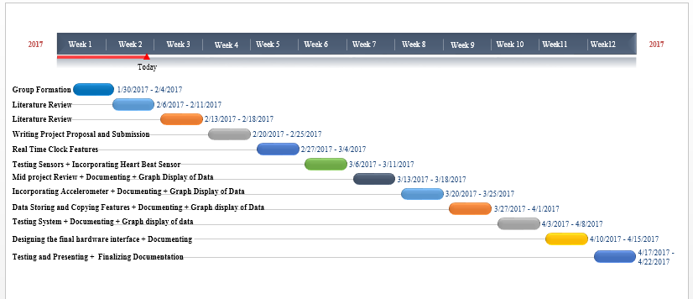

Fig 2 (Gantt Chart)

Group Breakdown Structure

The project is divided among the group members according to the following diagram fig (3).

